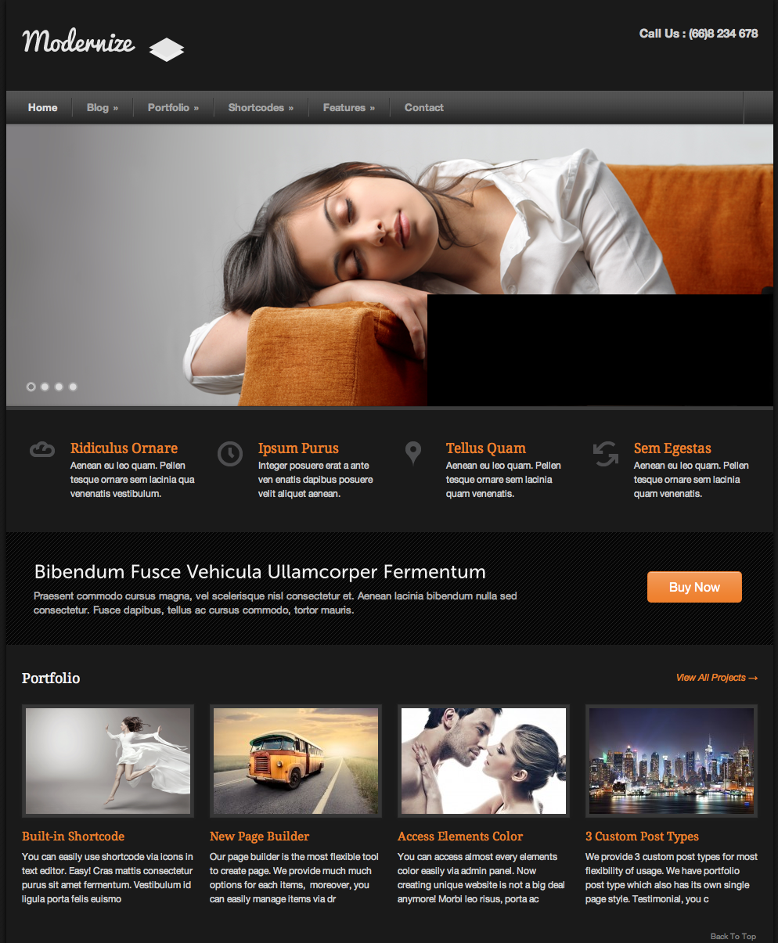

**Local**: C:\dev\CSS-exam

**Repo**: CSS-exam

**Branch**: Master

**Commit**: Created base project

**TODO**: ..

**Repo**: CSS-exam

**Branch**: Master

**Commit**: added background image and sized container appropriately

**TODO**: Add image log in upper left corner

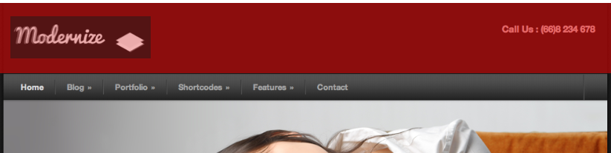

**Local**: C:\dev\CSS-exam

**Repo**: CSS-exam

**Branch**: Master

**Commit**: Added image log in upper left corner

**TODO**: Phone number in upper right corner

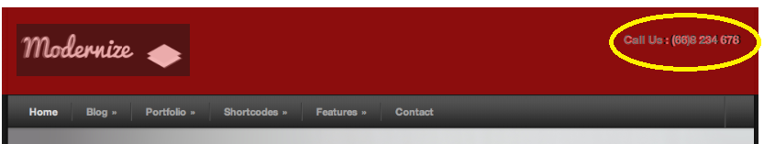

**Local**: C:\dev\CSS-exam

**Repo**: CSS-exam

**Branch**: Master

**Commit**: Phone number in upper right corner

**TODO**: Navigation bar

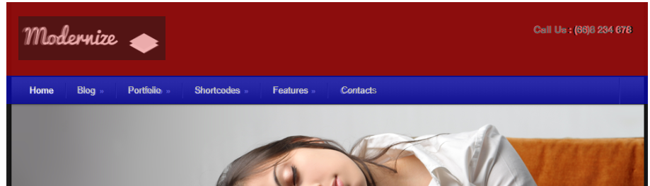

**Local**: C:\dev\CSS-exam

**Repo**: CSS-exam

**Branch**: Master

**Commit**: Added nav-bar with links

**TODO**: Add photo below nav-bar

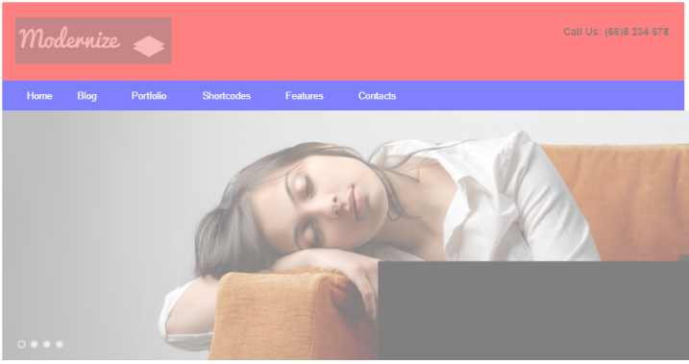

**Local**: C:\dev\CSS-exam

**Repo**: CSS-exam

**Branch**: Master

**Commit**: Added photo below nav-bar

**TODO**: Add links below nav bar

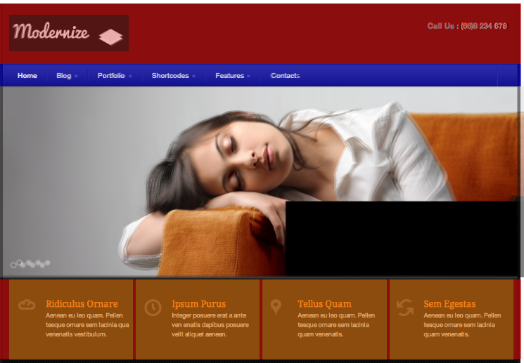

**Local**: C:\dev\CSS-exam

**Repo**: CSS-exam

**Branch**: Master

**Commit**: Added four columns in row below main-image

**TODO**: Add text in left-most col in row below main-image

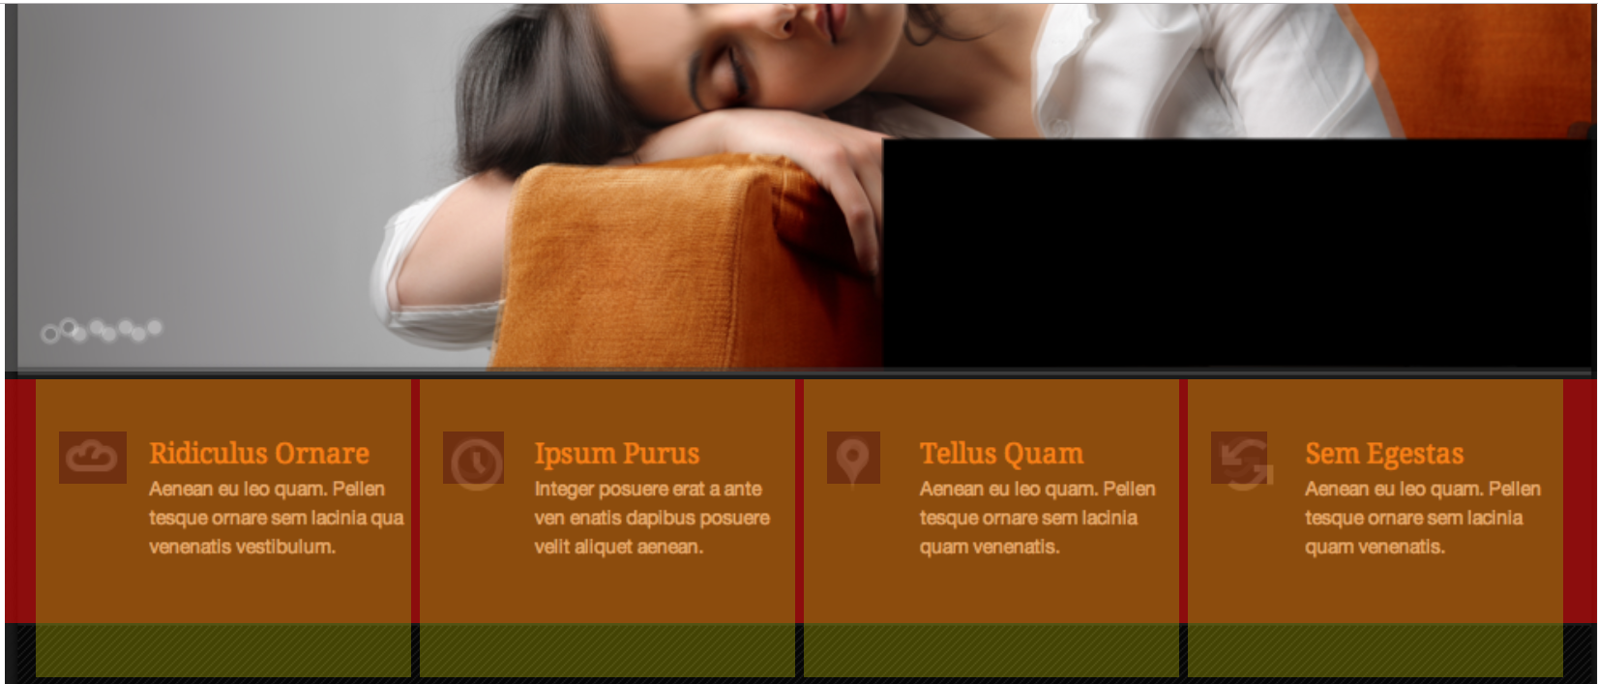

**Local**: C:\dev\CSS-exam

**Repo**: CSS-exam

**Branch**: Master

**Commit**: Added image in all four columns in row below main-image

**TODO**: Add text in left-most col in row below main-image

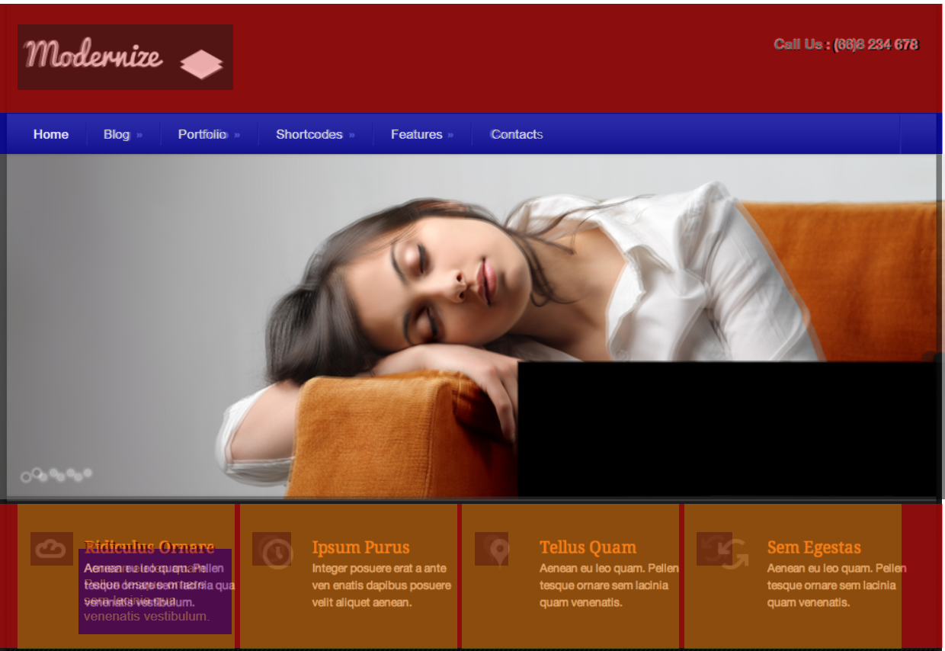

**Local**: C:\dev\CSS-exam

**Repo**: CSS-exam

**Branch**: Master

**Commit**: Added text in left-most col in row below main-image

**TODO**: Repeat for each col

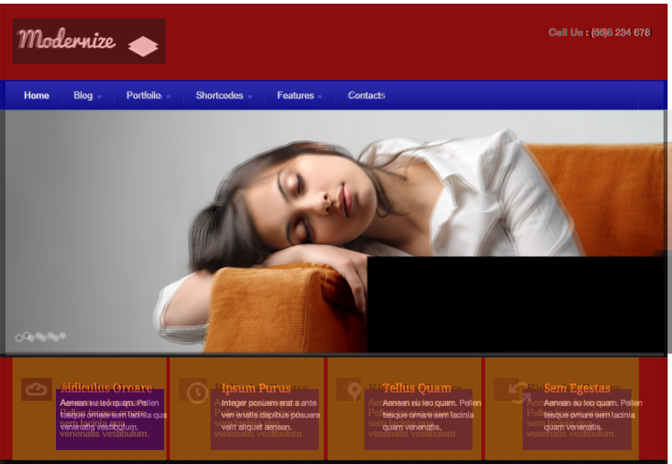

**Local**: C:\dev\CSS-exam

**Repo**: CSS-exam

**Branch**: Master

**Commit**: Repeated previous step for each col in the 4th -row

**TODO**:

* Create structure for 5th-row
* Fine-tune each col in the 4th-row
* Add background texture in row-5

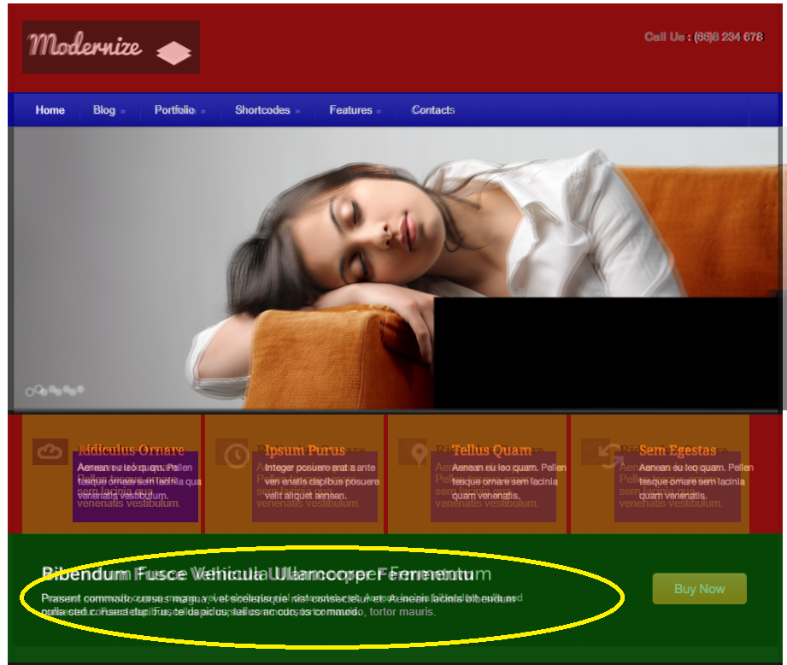

**Local**: C:\dev\CSS-exam

**Repo**: CSS-exam

**Branch**: Master

**Commit**: Added text in 5th -row

**TODO**:

* Create structure for 5th-row
* Fine-tune each col in the 4th-row
* Add background texture in row-5

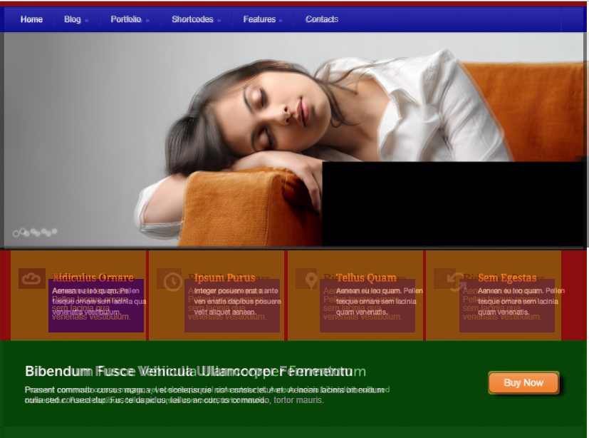

**Local**: C:\dev\CSS-exam

**Repo**: CSS-exam

**Branch**: Master

**Commit**: Added button in 5th-row

**TODO**:

* Create structure for 5th-row
* Fine-tune each col in the 4th-row
* Add background texture in row-5

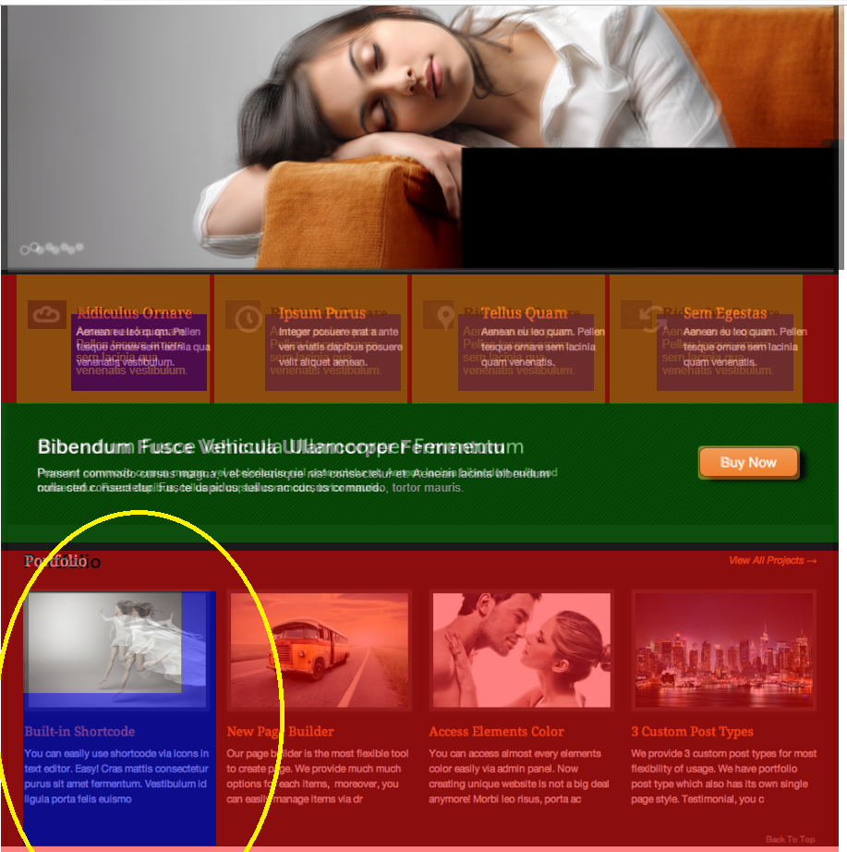

**Local**: C:\dev\CSS-exam

**Repo**: CSS-exam

**Branch**: Master

**Commit**: Added 6th-row and structure of first column within that row.

**TODO**:

* Create structure for 5th-row
* Fine-tune each col in the 4th-row
* Add background texture in row-5

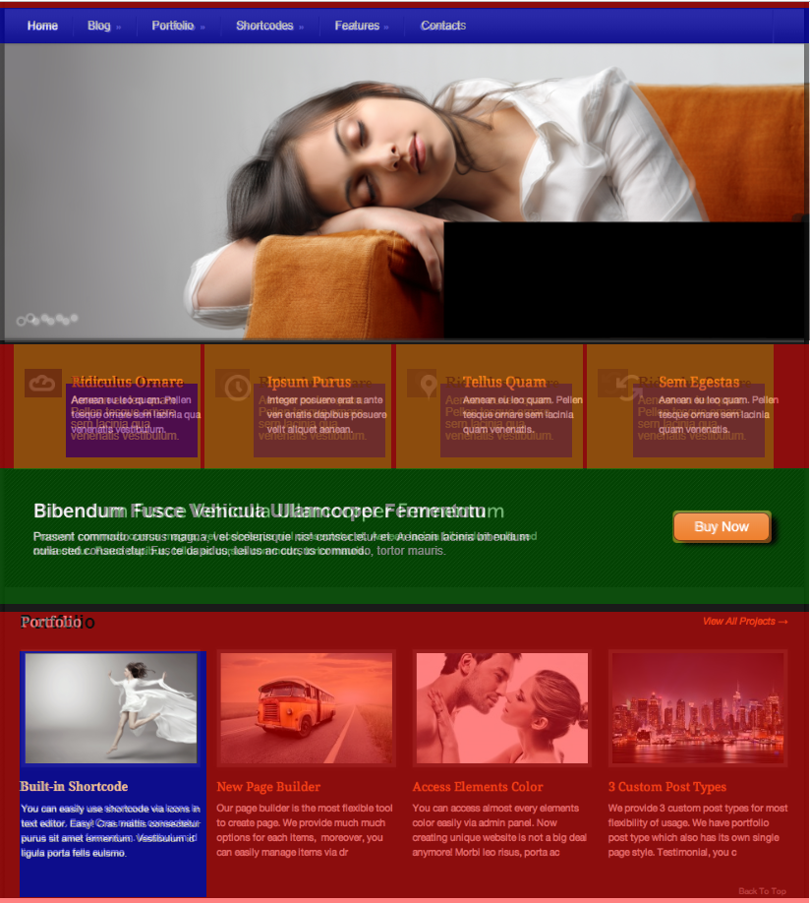

**Local**: C:\dev\CSS-exam

**Repo**: CSS-exam

**Branch**: Master

**Commit**: Added and formatted text in 1st-col of 6th-row

**TODO**:

* Create structure for 5th-row
* Fine-tune each col in the 4th-row
* Add background texture in row-5

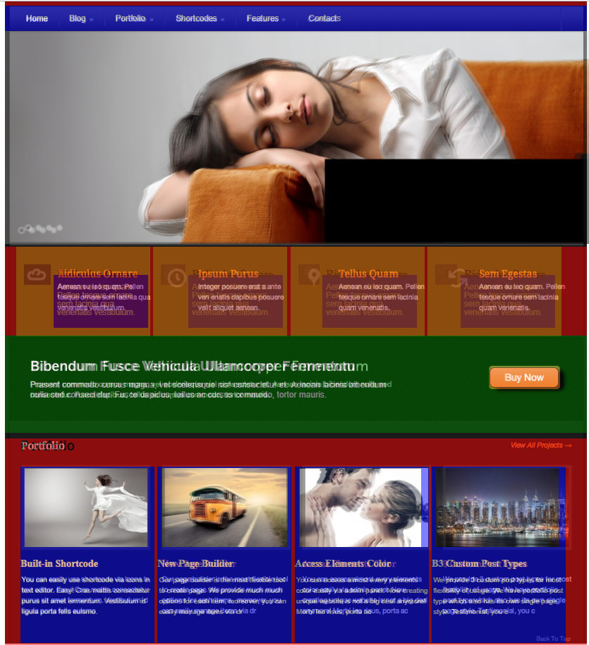 **Local**: C:\dev\CSS-exam

**Repo**: CSS-exam

**Branch**: Master

**Commit**: Added content for all cols in 6th-row

**TODO**:

* Create structure for 5th-row
* Fine-tune each col in the 4th-row
* Add background texture in row-5

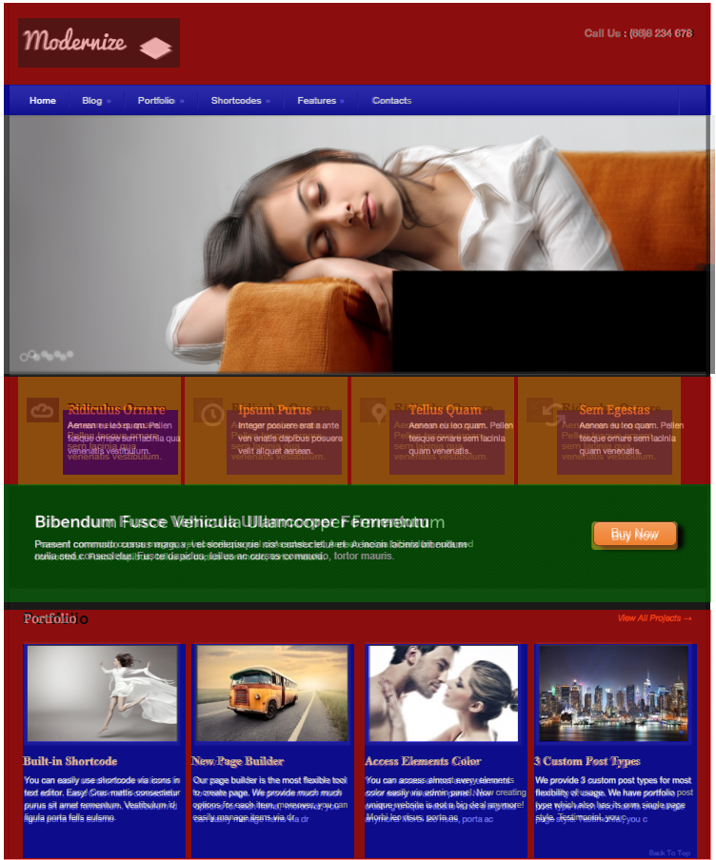

**Local**: C:\dev\CSS-exam

**Repo**: CSS-exam

**Branch**: Master

**Commit**: Aligned content of columns in 6th-row to a 1st-order approximation

**TODO**:

* Create structure for 5th-row
* Fine-tune each col in the 4th-row
* Add background texture in row-5
* Back-to-top link (bottom-right corner)
* View all projects link (upper-right corner of 6th-row)
* Add arrow in upper right link in 6th row.

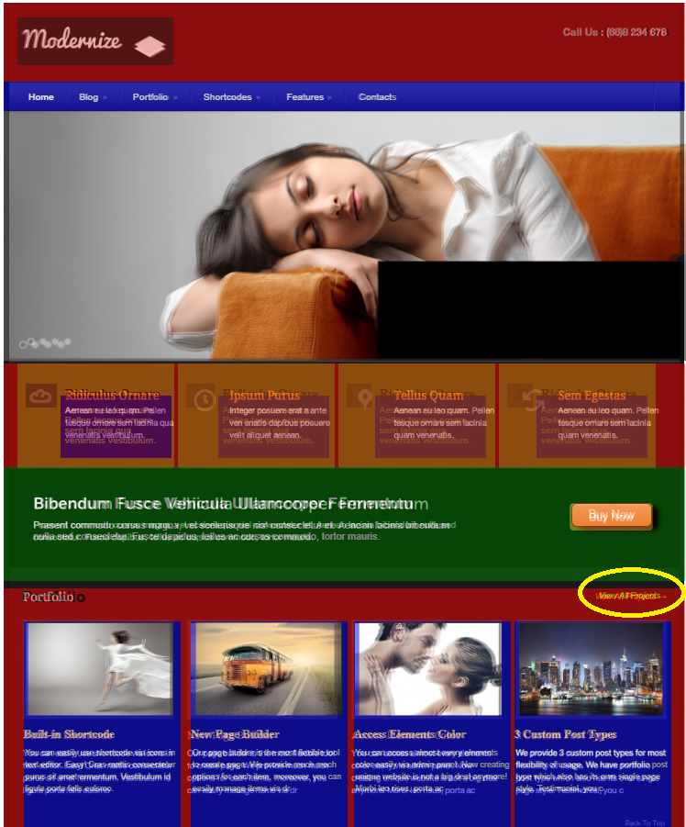

**Local**: C:\dev\CSS-exam

**Repo**: CSS-exam

**Branch**: Master

**Commit**: Added link named ‘View All Projects’

**TODO**:

* Add link in bottom right corner
* Match all background colors
* Create structure for 5th-row
* Fine-tune each col in the 4th-row
* Add background texture in row-5
* Back-to-top link (bottom-right corner)
* View all projects link (upper-right corner of 6th-row)
* Add arrow in upper right link in 6th row.

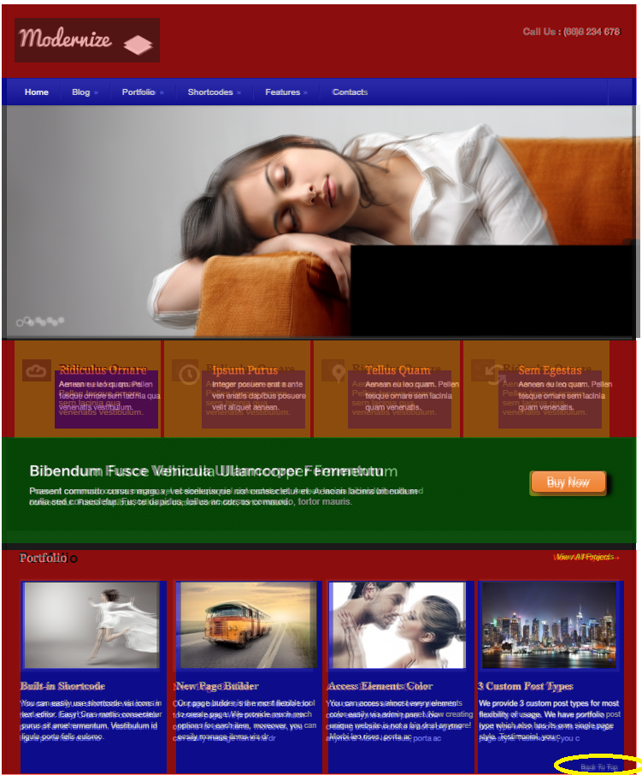

**Local**: C:\dev\CSS-exam

**Repo**: CSS-exam

**Branch**: Master

**Commit**: Added link in bottom right corner

**TODO**:

* Match all background colors
* Create structure for 5th-row
* Fine-tune each col in the 4th-row
* Add background texture in row-5
* Back-to-top link (bottom-right corner)
* View all projects link (upper-right corner of 6th-row)
* Add arrow in upper right link in 6th row.

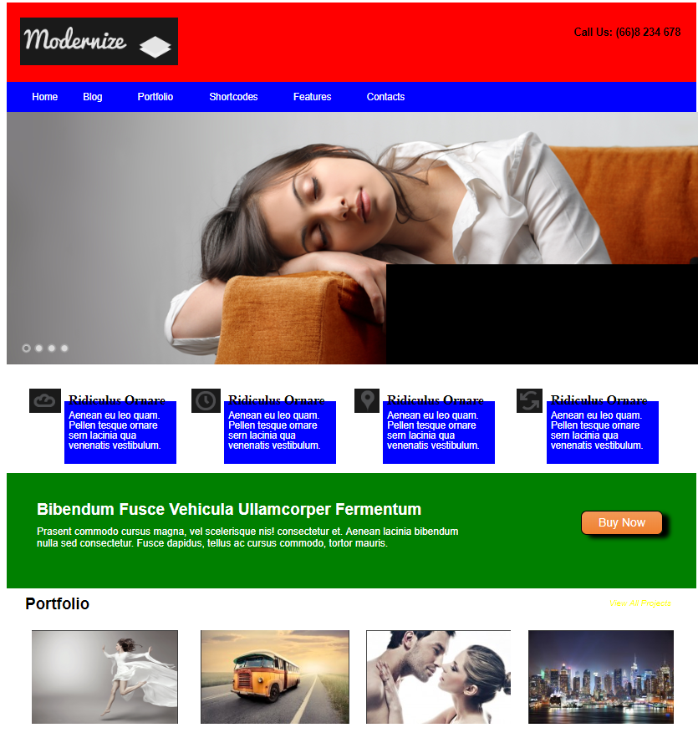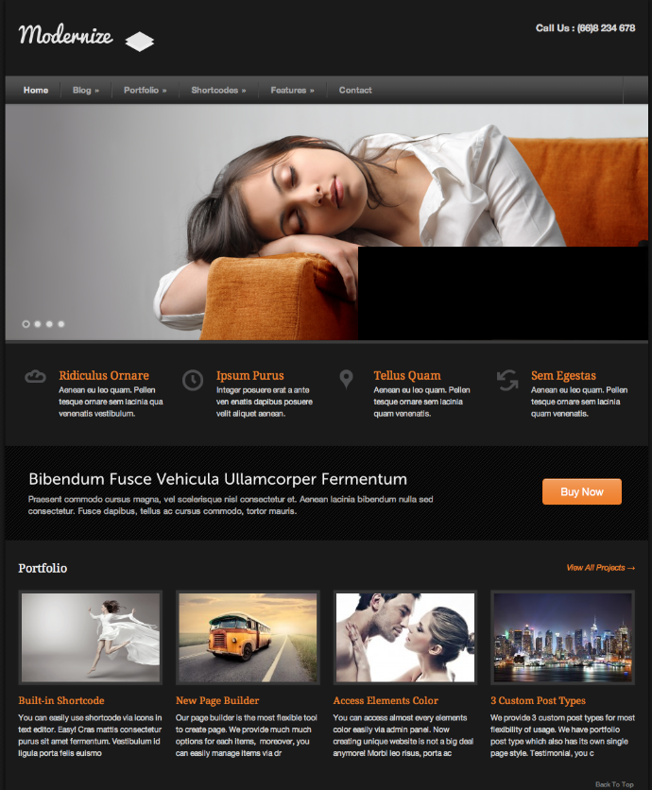

Removed debug settings

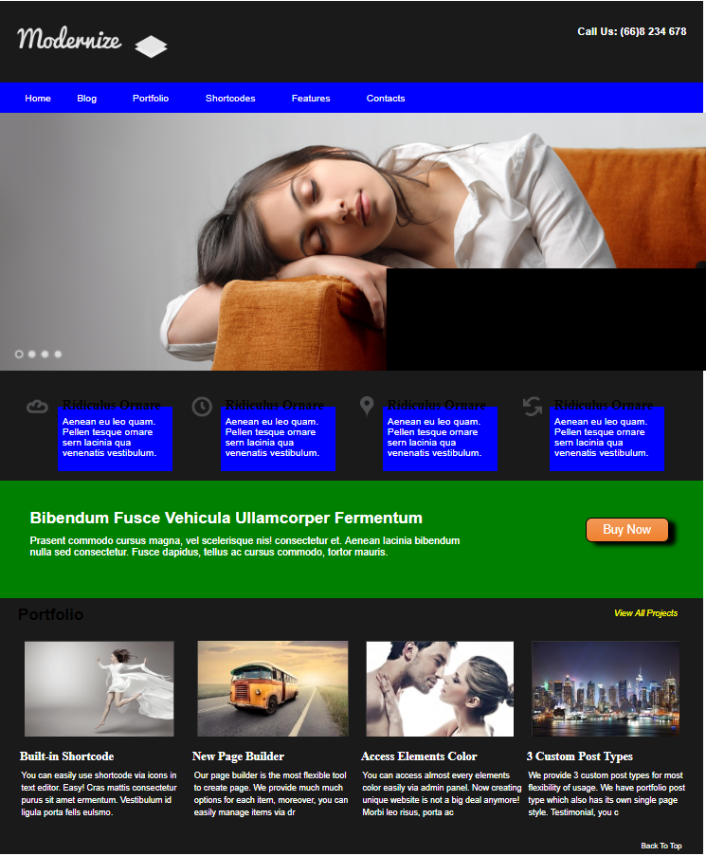

**Local**: C:\dev\CSS-exam

**Repo**: CSS-exam

**Branch**: Master

**Commit**: Began matching background colors

**TODO**:

* Match all background colors
* Create structure for 5th-row
* Fine-tune each col in the 4th-row
* Add background texture in row-5
* Back-to-top link (bottom-right corner)
* View all projects link (upper-right corner of 6th-row)
* Add arrow in upper right link in 6th row.

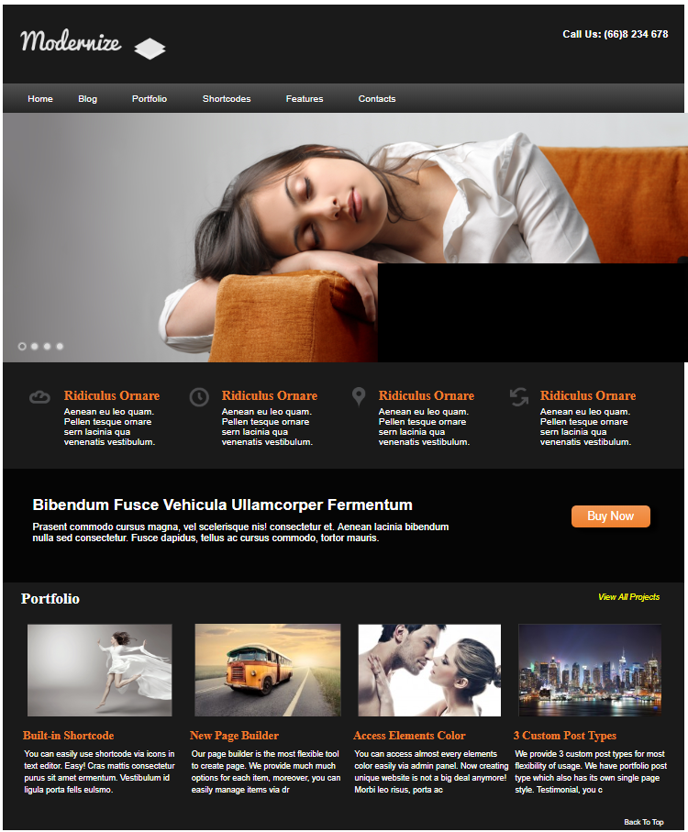

**Local**: C:\dev\CSS-exam

**Repo**: CSS-exam

**Branch**: Master

**Commit**: Finished matching most colors

**TODO**:

* ~~Match all background colors~~
* Border around images in bottom
* Fine-tune each col in the 4th-row
* Add background texture in row-5
* Back-to-top link (bottom-right corner)
* View all projects link (upper-right corner of 6th-row)
* Add arrow in upper right link in 6th row.

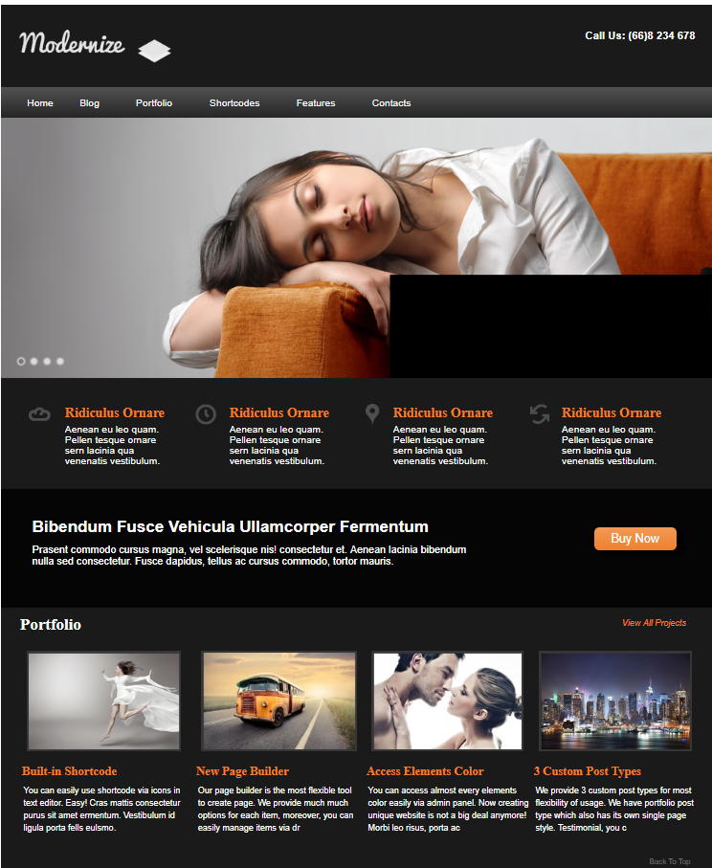 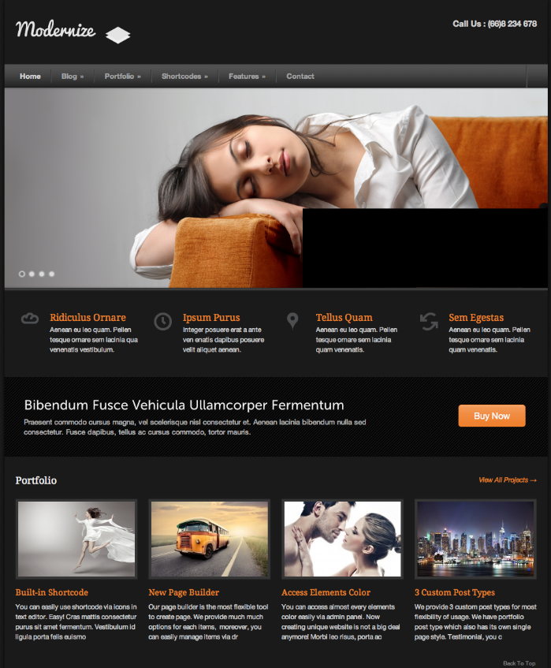

**Local**: C:\dev\CSS-exam

**Repo**: CSS-exam

**Branch**: Master

**Commit**: Border around images in bottom. Fixed width of main image.

**TODO**:

* ~~Match all background colors~~
* ~~Border around images in bottom~~
* Fine-tune each col in the 4th-row
* Add background texture in row-5
* Add arrow in upper right link in 6th row.

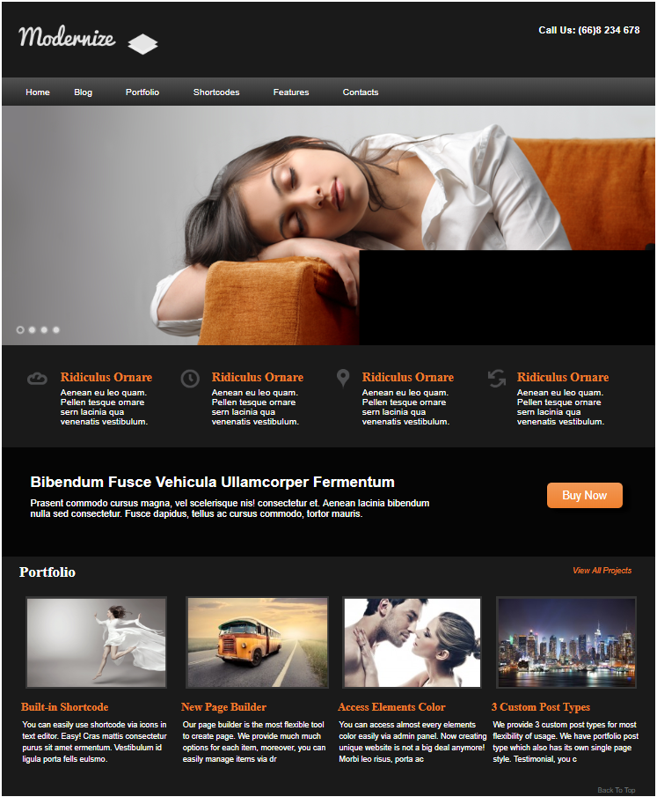

**Local**: C:\dev\CSS-exam

**Repo**: CSS-exam

**Branch**: Master

**Commit**: Made ‘Buy Now’ link taller

**TODO**:

* Fine-tune each col in the 4th-row
* Add background texture in row-5
* Add arrow in upper right link in 6th row.